A Quick Guide to the DynaKars
Setting up the DynaKar
1) Switch on car (slow flashing)
2) Hold pairing button until the light is flashing quickly
3) Quickly plug in the dongle (the light will go out)
4) Start Logbook graphing software. It should now see the car
Troubleshoot: exit software, unplug dongle, switch off car, REPEAT. You might need to chage USB port- some are faster than others.
LogBook Graphing
You can set up a graph by pressing the 'measure' and then 'dynakar Qlog' button
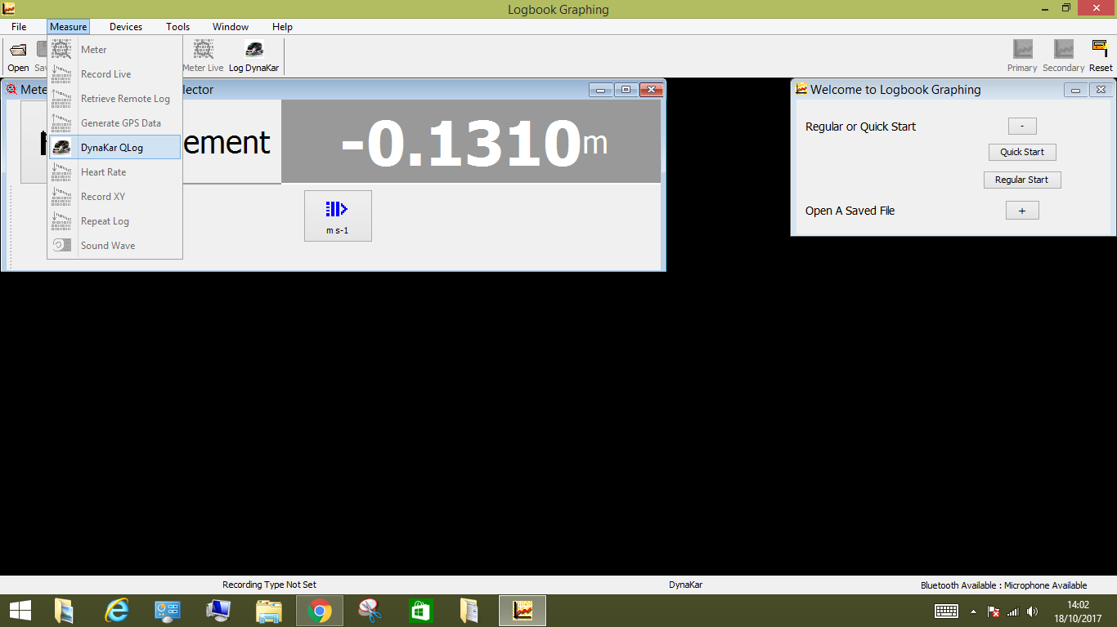
You will see a Distance-time graph (red) or a speed-time graph (blue)
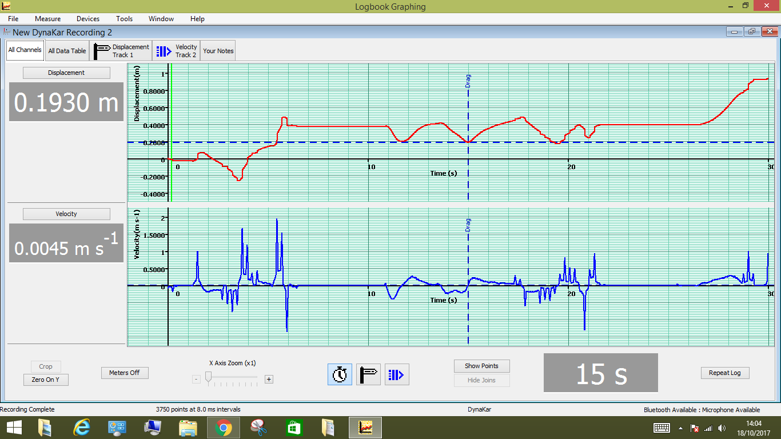
Moving the car around will give you a graph.
You can remove the graphs by clicking on 'displacement' or 'velocity'
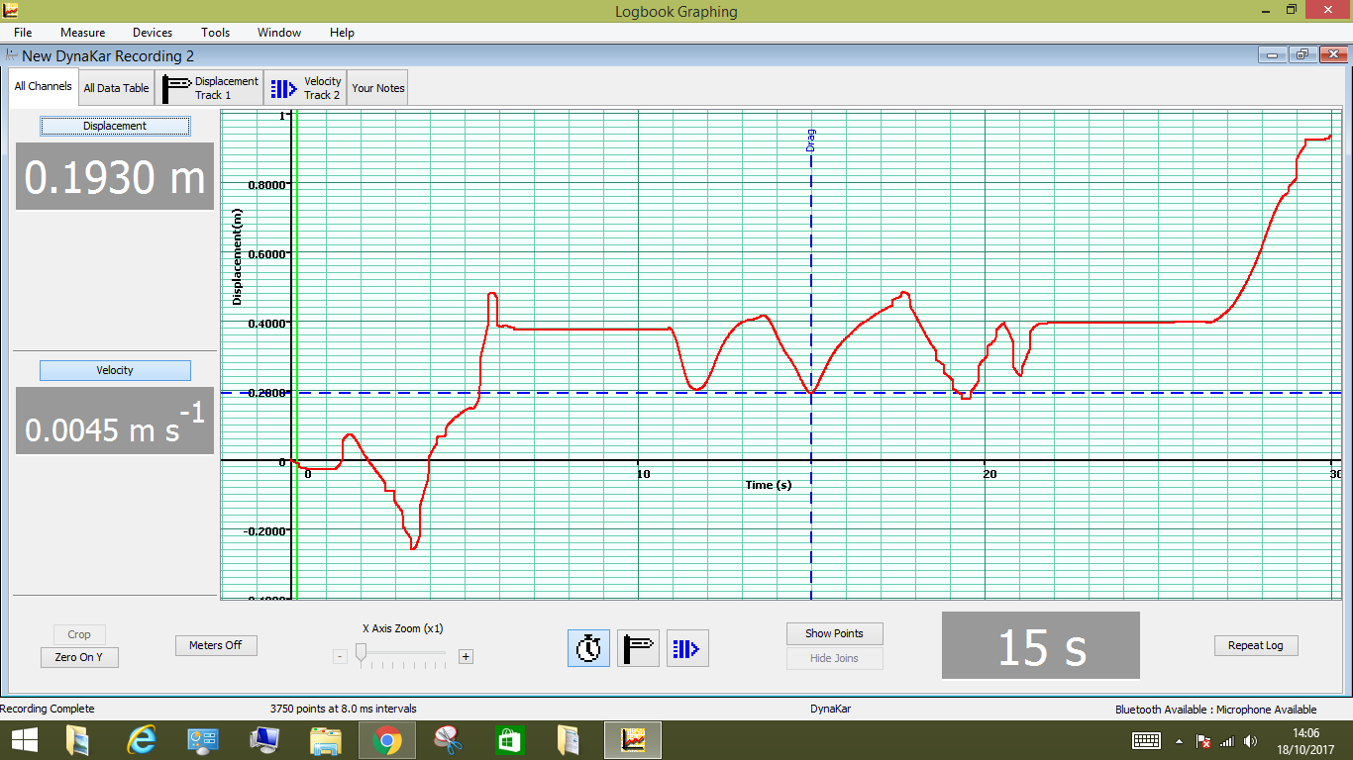
You can change the recording time by pressing here. You have to have chosen regular start at the beginning to use this.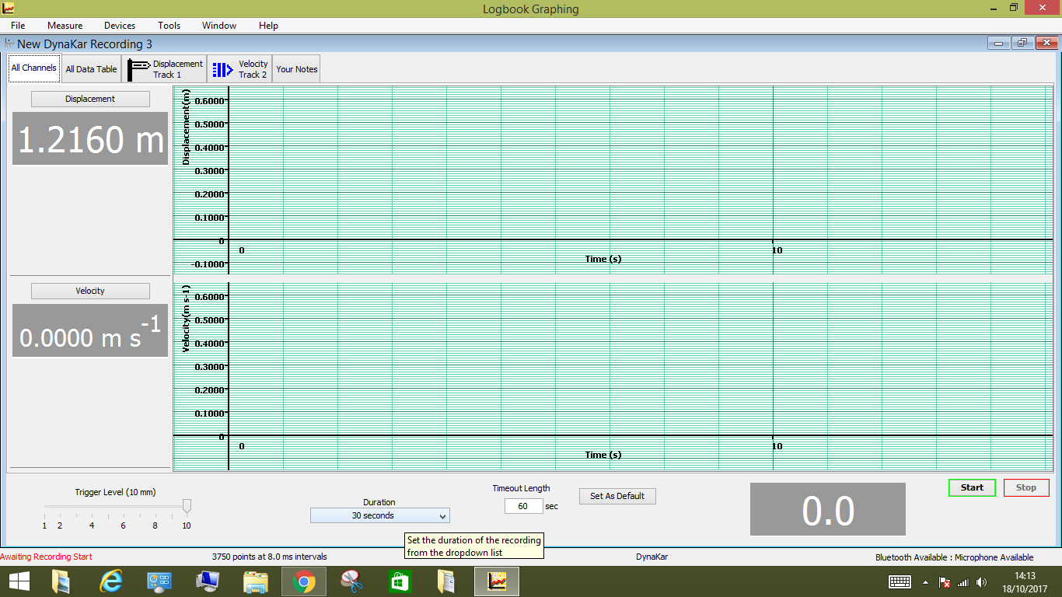
You can take a new recording by pressing here.
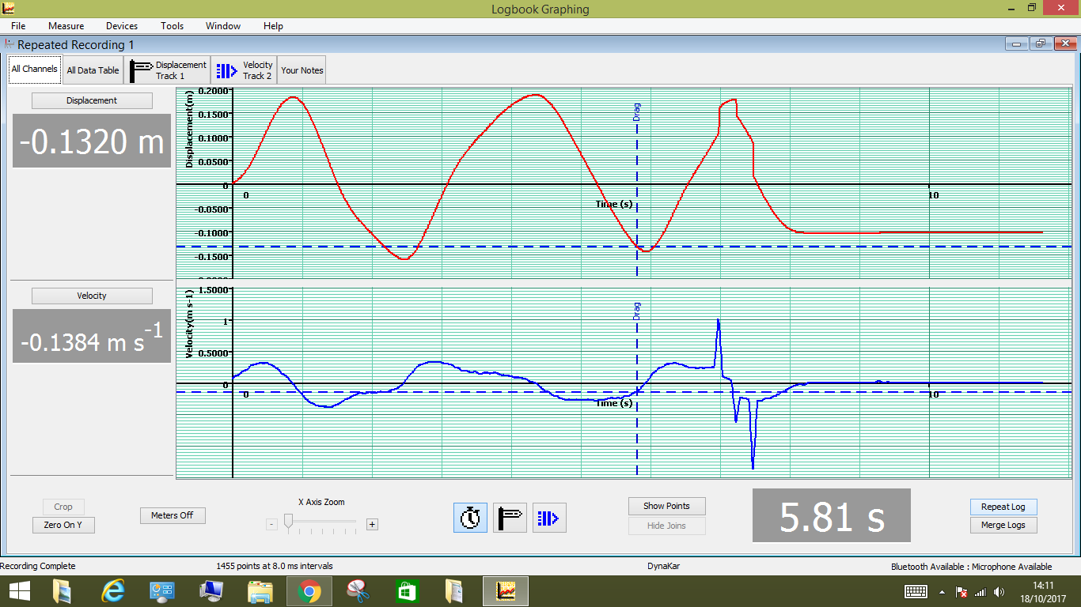
You can take up to 10 recordings before you will have to delete a graph.
You can find the speed on a distance-time graph by clicking on point on the line and dragging. Hovering your mouse over the blue area will give you the area under the graph and the slope.
You can find the acceleration or the distance on a velocity-time graph by clicking on point on the line and dragging. Hovering your mouse over the blue area will give you the area under the graph and the slope.
Activities to do with dynaKars:
Investigate shapes of D-T and V-T graphs
Have the students move the cars at a constant speed, accelerating, decellerating, staying still, forwards, backwards and sketch the shapes.
Match the shapes
Draw shapes on the board and have the students try to recreate them with the dynakars
F=ma
Attach the dynakar to a pulley and masses and investigate force vs acceleration by finding the gradient of the v-t graph for different masses.

