How to use the data loggers (example- temperature sensor)
1) Switch on and log onto your computer. The password is 'password'. This should take no more than 3 mins.
2) plug your uLog sensor into the USB socket.
3) Open Sensor Lab and you should see this:
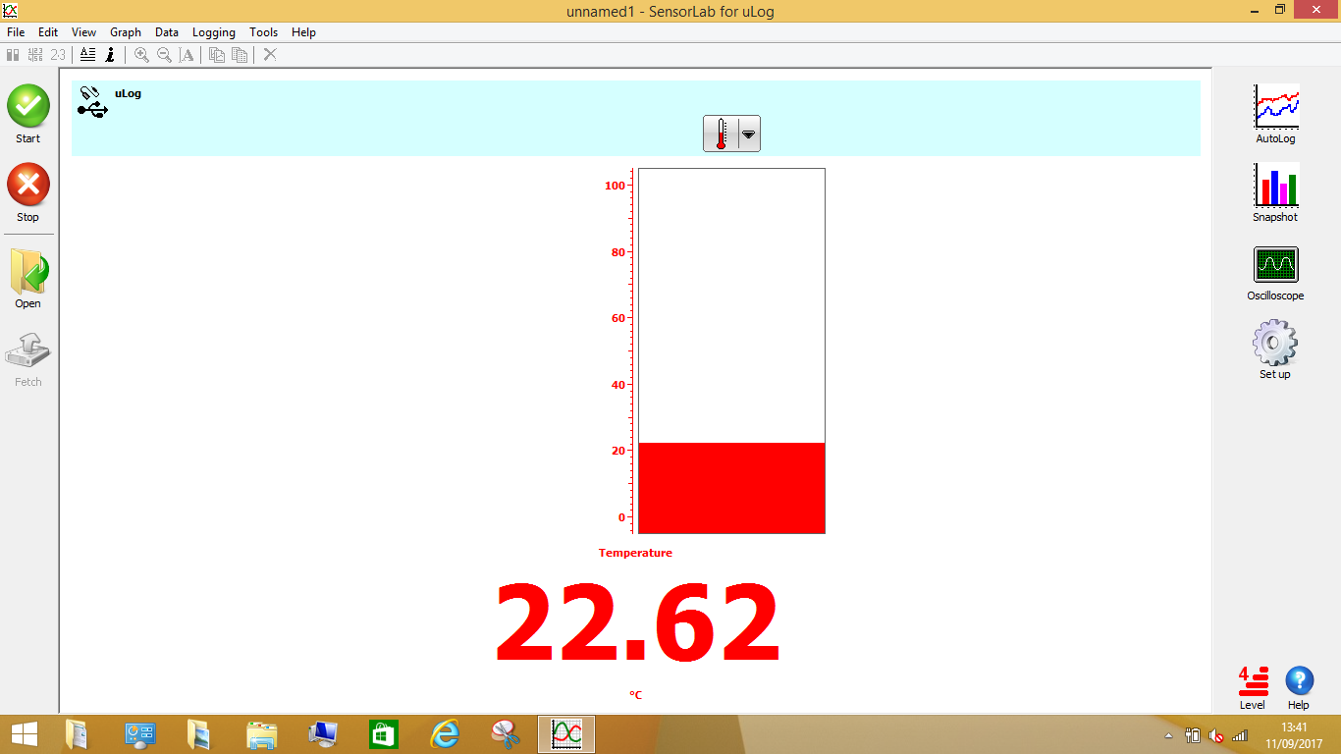
4) Clicking on 'graph' on the right will give you this view:
You can edit what is on each axis by double clicking on them:
And change the scale by double clicking on the table headings.

can stop and start to take multiple readings using the 'logging' tab.
You can then zoom or copy the graph or data using the buttons along the top:

This is what it will look like if you copy the graph into Microsoft Word. Remember, the laptops don’t have a copy of Microsoft office but the pupils can access it online if they log into their office 365 accounts. 