Investigating Uniformly Accelerated Motion using Scratch.
15mins Building, 15 mins running

Introduction
We are going to be looking at a ball fired from a cannon. You might want to look at your basketball dropping simulation and borrow some of the code.

To think like a computer you need to start thinking in the following way:
Position is how we are going to define our object.
Velocity is a change in ____________________
Acceleration is a change in ________________

Building the model
- First things first, let’s change the background. Click on the stage and import a background. I chose corn field. You can use one from the program or find one on the internet and save it.
- Next you need to make a ‘sprite’. This is just an object that moves. Click on the scissors in the top right and then click on the cat to delete it.
- Click on the new sprite from folder button and choose a ball.
- It’s a little big so make it smaller by clicking on the minimise button and then on the ball.
- Then you’re also going to need to add a new sprite for the cannon.

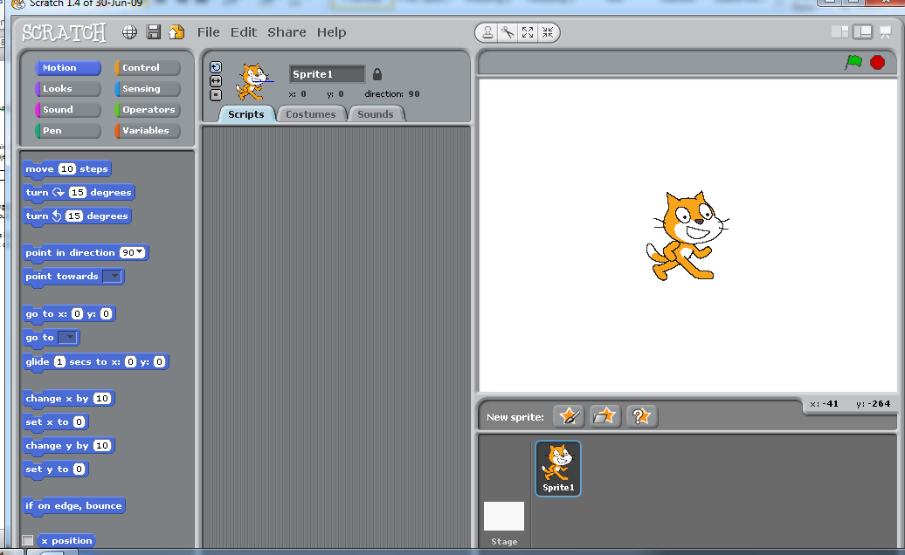
Click on the stage and import a new background
Make the ball smaller
Insert a ball
Delete the cat

Thinking about the Physics
- We’re going to be working with four different tabs:
  - Motion- whenever we want to do anything with position
  - Control- whenever we want to do anything with the program ie. Starting, looping
  - Operators- whenever we want to do any maths
  - Variables- whenever we want to change anything we have made. We will be making two variables: velocity and acceleration.
- Computers are excellent at thinking about motion independently because the sprites are defined by x position and y position.
- Let’s think about how the position of our ball should change as it falls.
  - Every second, how much does the x position change by?.................................
  - Every second, how much does x the velocity change by?...............................
  - Every second, how much does the y position change by?................................
  - Every second how much does the y velocity change by? ……………………………..
- Let’s put these into some equations:
New velocity = velocity +…………………….
New Position = position +…………………….
- We’re going to loop through these two equations each second and have a look at how the ball’s position changes.

Putting this into the program:

- First we need to make the program start. Click on the sprite and then choose the control options. Drag the ‘when clicked’ option onto the screen. This will start our program.
- When the flag is clicked, we want our ball to return to the starting position. To do this we’ll need the motion tool.
Drag the got to button onto the drawing board. Move your sprite to its start position and hover the mouse over to see what the coordinates are. Fill those in.
- We’ll also want to reset the velocity. Go into the variables section and create two variables: x velocity and y velocity
- Then choose ‘set to’ and drag it into the jigsaw. This is where you’ll be able to change the initial velocity of the cannon.
- We’re also going to want to make a variable called acceleration. Set that to -9.81.
- Now let’s make it shoot. We’ll make it start on a space bar hit. So go to control and choose ‘When space is hit…’
- We want it to keep falling until it hits the ground so choose repeat until. It hits the ground when the y position is -150. We’re going to need to put an operator in. Choose the less than option
Then take the ‘y position’ from the motion tab and make y position < -150.
- Each loop our y velocity has to increase by the acceleration so in the variables tab choose ‘set velocity to’ and put in an operator to make it velocity + acceleration. Remember you have to drag the variable names in from the variables tab.
- Then we want the ball to move so we need to change the y position by the y velocity and the x position by the x velocity. Use the function in the motion tab.
- If you want to see the progress of your ball go to the pen tab and choose ‘stamp’
- Start you program and see how it goes!

A* Extension: In a real cannon, the cannon would move backwards once it fired. Add code to the cannon sprite to make it look better.

This is what it should have at the end:

Questions on the Program:
Easy: What do you have to do to make the cannon shoot further? Higher?

Medium: Find the speeds that make it go the furthest and the highest.

Hard: add your vectors to find the angles that make it go the furthest.

